Radio Buttons
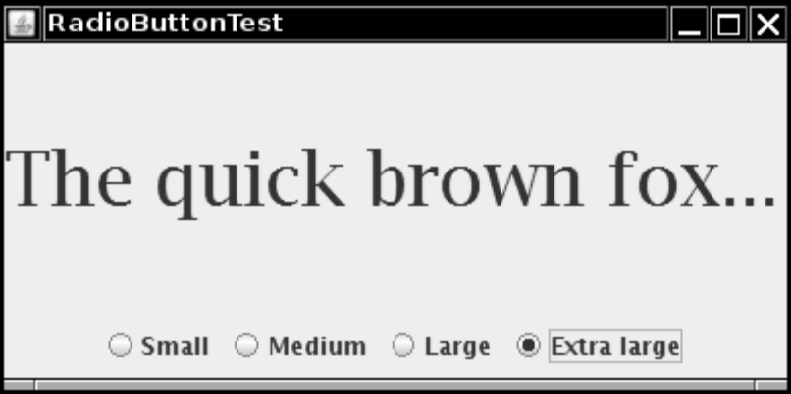

import java.awt.*;
2. import java.awt.event.*;
3. import javax.swing.*;
4.
5. /**
6. * @version 1.33 2007-06-12
7. * @author Cay Horstmann
8. */
9. public class RadioButtonTest
10. {
public static void main(String[] args)
12. {
13. EventQueue.invokeLater(new Runnable()
14. {
15. public void run()
16. {
17. RadioButtonFrame frame = new RadioButtonFrame();
18. frame.setDefaultCloseOperation(JFrame.EXIT_ON_CLOSE);
19. frame.setVisible(true);
20. }
21. });
22. }
23. }
24.
25. /**
26. * A frame with a sample text label and radio buttons for selecting font sizes.
27. */
28. class RadioButtonFrame extends JFrame
29. {
30. public RadioButtonFrame()
31. {
32. setTitle("RadioButtonTest");
33. setSize(DEFAULT_WIDTH, DEFAULT_HEIGHT);
34.
35. // add the sample text label
36.
37. label = new JLabel("The quick brown fox jumps over the lazy dog.");
38. label.setFont(new Font("Serif", Font.PLAIN, DEFAULT_SIZE));
39. add(label, BorderLayout.CENTER);
40.
41. // add the radio buttons
42.
43. buttonPanel = new JPanel();
44. group = new ButtonGroup();
45.
46. addRadioButton("Small", 8);
47. addRadioButton("Medium", 12);
48. addRadioButton("Large", 18);
49. addRadioButton("Extra large", 36);
50.
51. add(buttonPanel, BorderLayout.SOUTH);
52. }
53.
54. /**
55. * Adds a radio button that sets the font size of the sample text.
56. * @param name the string to appear on the button
57. * @param size the font size that this button sets
58. */
public void addRadioButton(String name, final int size)
60. {
61. boolean selected = size == DEFAULT_SIZE;
62. JRadioButton button = new JRadioButton(name, selected);
63. group.add(button);
64. buttonPanel.add(button);
65.
66. // this listener sets the label font size
67.
68. ActionListener listener = new ActionListener()
69. {
70. public void actionPerformed(ActionEvent event)
71. {
72. // size refers to the final parameter of the addRadioButton
73. // method
74. label.setFont(new Font("Serif", Font.PLAIN, size));
75. }
76. };
77.
78. button.addActionListener(listener);
79. }
80.
81. public static final int DEFAULT_WIDTH = 400;
82. public static final int DEFAULT_HEIGHT = 200;
83.
84. private JPanel buttonPanel;
85. private ButtonGroup group;
86. private JLabel label;
87.
88. private static final int DEFAULT_SIZE = 12;
89. }

